**JMeter**

**Chapter 1: Performance Testing Basics**

-------------------------------------------------

**What is JMeter:**

--------------------

JMeter is a Open source tool which is using for Load Testing and Measure the Web applications performance.

**Performance Testing:**

---------------------------

Testing the Application to Apply the different kinds of load is called Performance Testing. In this we have different types of performance testing

**1.Responce Time Testing:**

--------------------------------

Verifying the time taken by the server to return a response to the client is called Response time testing.

**2.Load Testing:**

-------------------

Verifying the time taken by the server to return a response to the all client. It will be conducted for more than one user. In Load testing we evaluate the server performance whether it can Accept the incoming Load traffic and give successful response to all the clients.

**3.Stress Testing:**

--------------------

Verifying if the client that submitted their requests to the server. Will time-out after waiting for certain duration : The client will time-out when they reach the break-even point time: The Clients will throw time-out error when break even point is met and eventually disconnect their connection with the server.

**4.Soak Testing:**

-------------------

Verifying the server behavior when the client request are sent continuously for a longer duration of time is called as endurance/soak testing. This is usually conducted for ecommerce applications which are excepted to work round the clock 24*7.

**Response Time** :

---------------------

The Time taken By the server to give response to the Client : Response time usually measure in Milli Seconds

**Connection Time**:

Time taken by Client to establish connection with the server

**Latency:**

The time taken by sever to send 1St Packet/1St Byte of the full response to the Client is called As Latency : Latency usually will Measure in Milli-seconds

**Error Rate:**

The % of errors [4xx or 5xx series] received from the server to the client is called error rate

4xx 🡪 400 to 499 = Client side errors

5xx 🡪 500 to 599 = Server side errors

**Throughput:**

The Number of incoming Client Request that can be processed by server Over a period of time such as milli-seconds/Seconds/minutes is called as Throuput.

**JMeter Test Plan & Test Elements:**

--------------------------------------------

Here We have different types of Elements

***1.Thread Group***

***2.Sampler***

***3.Listener***

***4.Assertions***

***5.Test Fragment***

***6.Config Elements***

***7.Pre Processors***

***8.Post Processors***

***9.Logic Controller***

***10.Non Test Elements***

1.**Thread Group (Users):**

-------------------------------

Thread Group we must create Under Test Plan and Here Each thread will act as Virtual User. Here we can create Number of virtual users

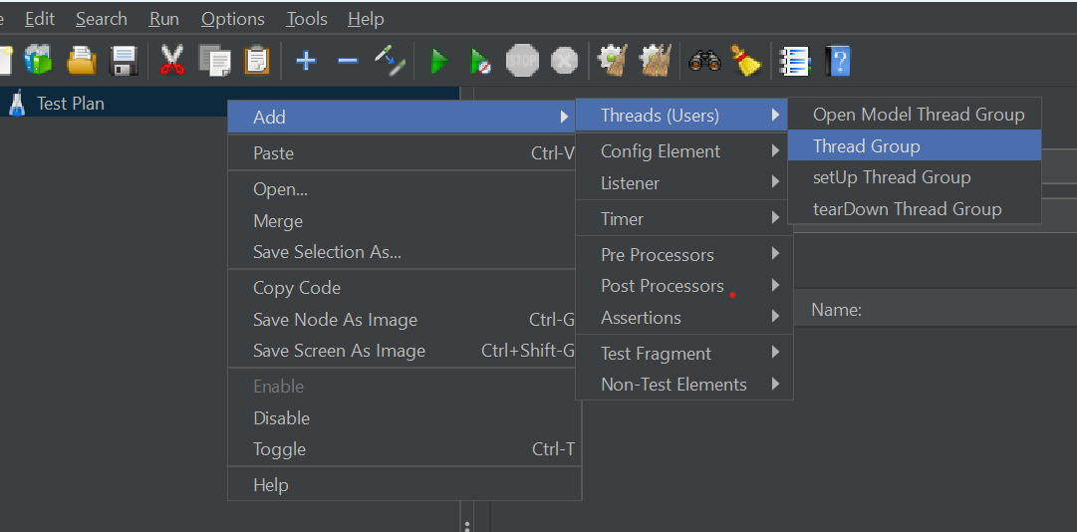

**2.Sampler:**

We Can Submit or Send the Request From the JMeter Client to Server. Using Smpler test element we Can Send Any Kind Of Request to Server Like http , https , FTP , JDBC …etc.

Note : We can add as many Sampler Under Thread Group

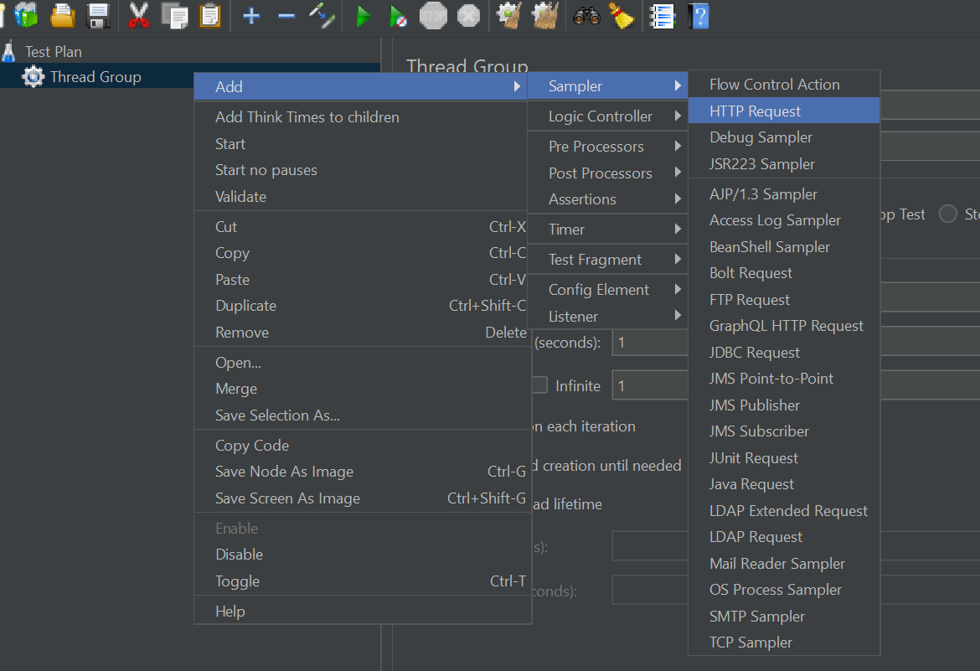

**3.Listeners:**

Using Listener JMeter Capture the Server Response and Populate The Test metrics such as response time, Connection time, Throughput , Latency ,error rate etc.

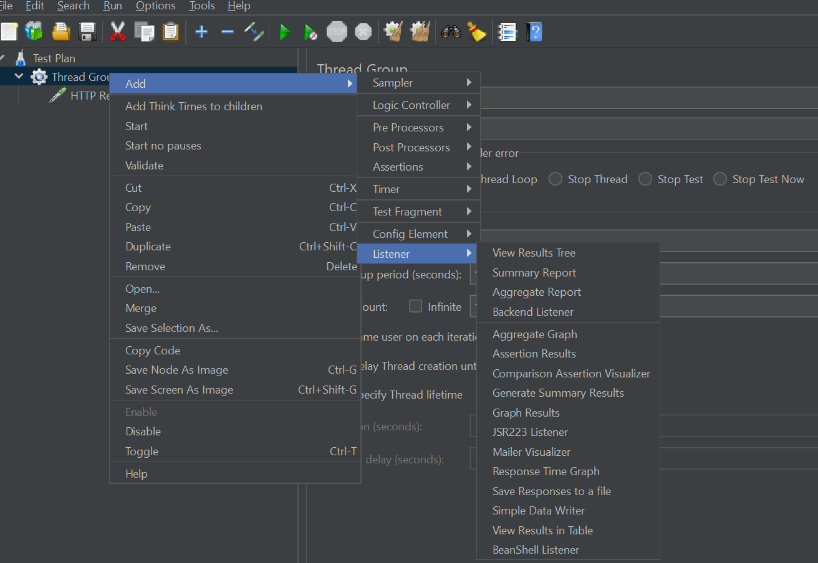

**4.Assertion:**

Assertion is nothing But Validation. Here we will Check the Response Wheater Server sending Correct data or Wrong data.

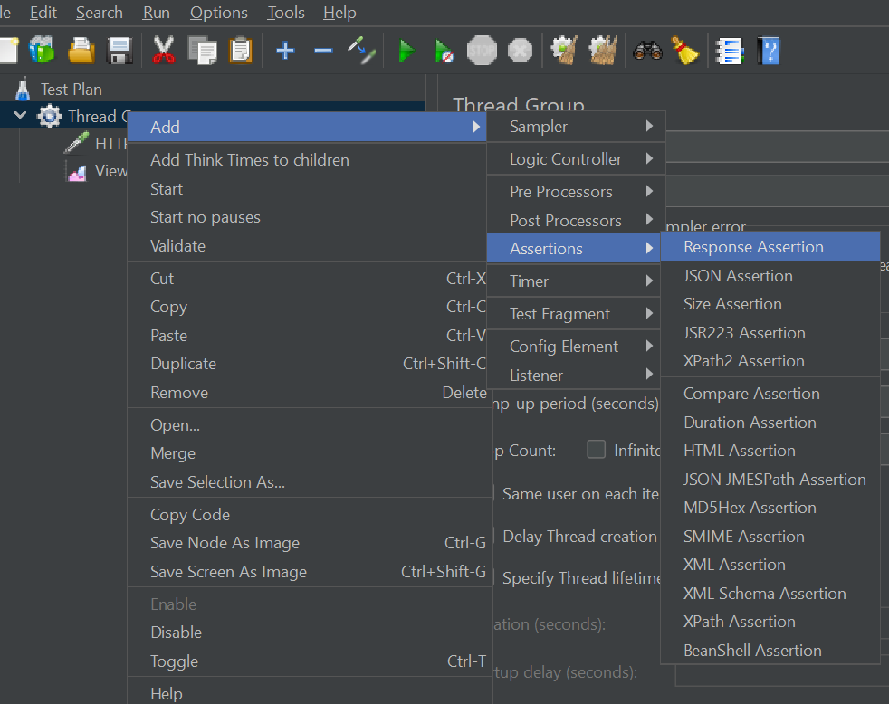

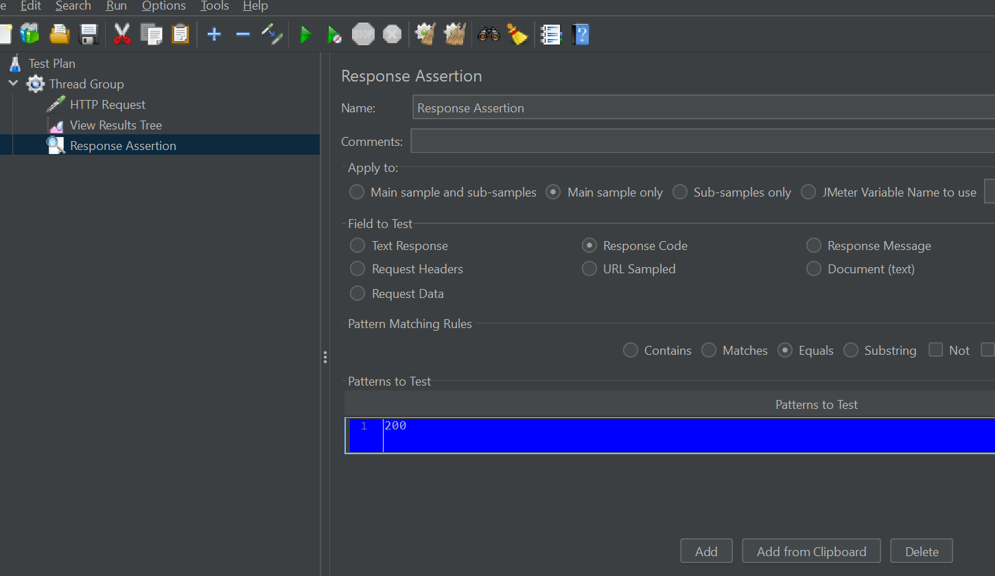

**5 Logic Controller:**

Logic controllers helps in Executing the JMeter Test in the Order of Execution User Wants. if user want execute the Test Multiple time or particular request number of time ..etc.

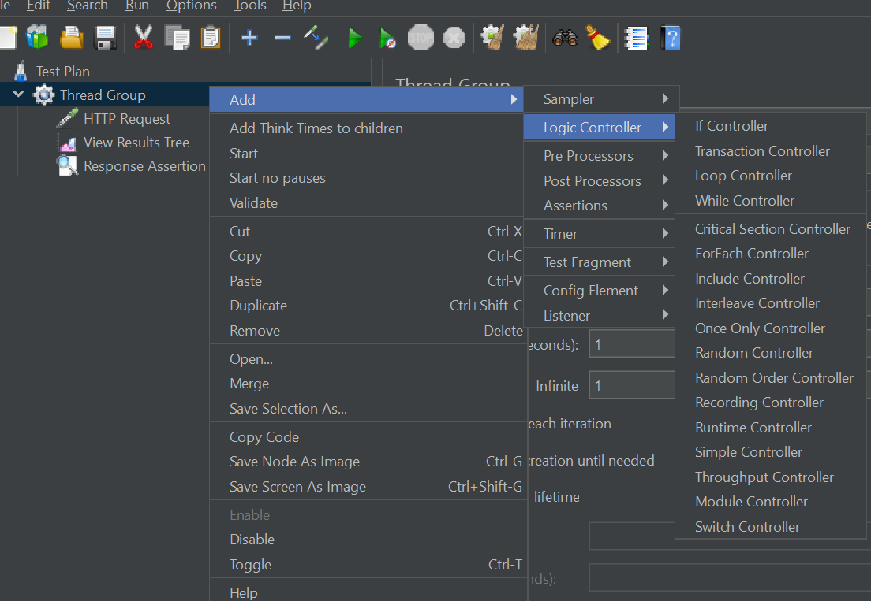

**6.Test Fragment:**

This is a dummy non executable element in JMeter

**7.Timers:**

Timers simulate real user behavior during performance testing as they create the required delay time during executing the Test

**8.Non-Test Elements:**

The HTTPS Test Script Recorder is Used to Record the User Actions Conducted on the Browser to generate JMeter Test Script Automatically

**9.Config Element:**

Config Elements are used to simulate Real time Browser Behavior in the JMeter Tool.

**10.Pre-Processors:**

Preprocessors are added at a sampler level and are Executed before the sampler is executed.

**11. Post Processors:**

Post Processors are added at a sampler level and are executed after the sampler is executed

***Note: JMeter Will run the performance test in The Back end using Headless browsers mode***

**How to Test Curl:**

If User want test Curl in JMeter have one Option called Import from Curl.

Click on Tools and Select Import from curl option

Note : Before Pasting the Curl We Must Remove the “^” Icon Other wise It will Throw Error message .



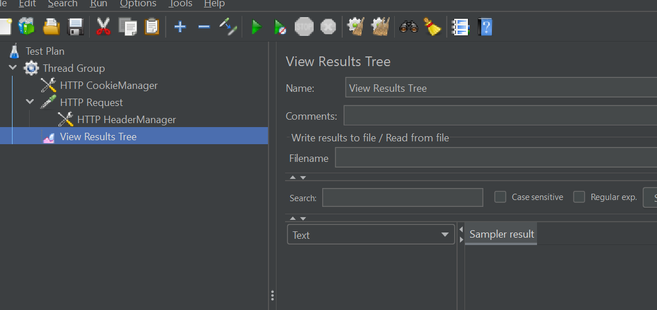

After Creating Thread Group Change The Thread Group numbers and Ram-up time and Loop Count.

**How to Check Graph Result:**

------------------------------------

In Graph Result mainly we focus on Throughput time and Average and Deviation

Throughput always should high and Average and Response , Deviation should be medium or Low

**Simple Data Writer:**

-------------------------

Simple Data Writer is a Listener which is used to save the Test Data. if you want to save the test data Right Click on thread Group, go to Listeners and Select the Simple data writer.

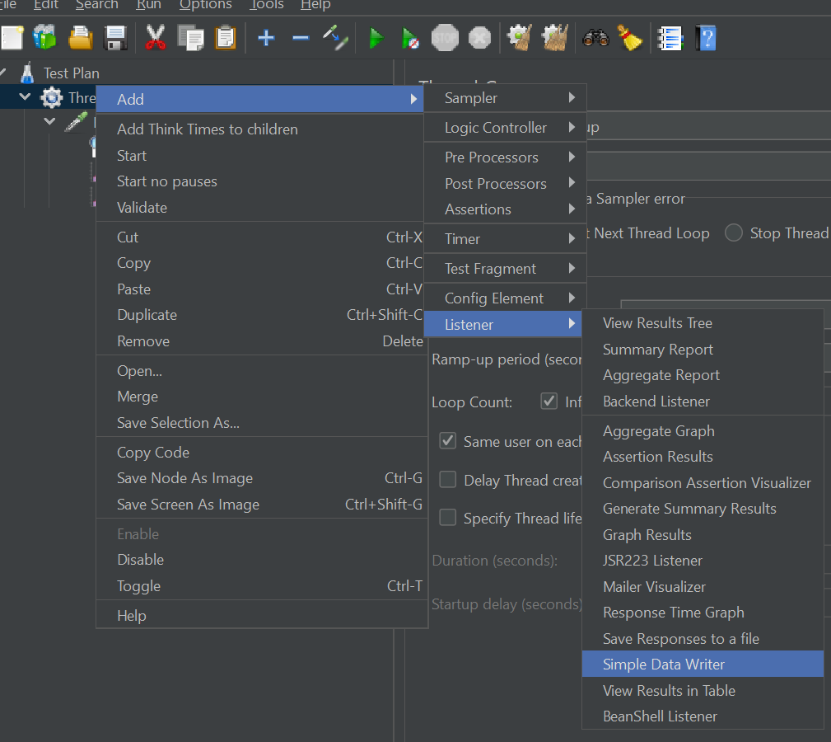

In File name text field give the File path and the File extends should be .csv. if you want Save the Only successfully Result Click on Success Check box or if you want to save Error message, Click on Errors Check box or else if you want to Save the All the Result Do not Select any Check box.

**How to Simulate a Real Time Browser:**

-----------------------------------------------

By default, JMeter will not act as Real time Browser it always sent request to serve Apache HTTP Request, but in real time user will not send this kind of request so Simulating Realtime browser we have to tell the JMeter. For the we have Config Elements. In Config Element we have a method called HTTP Heade Manager. Through the HTTP Header manager we can send a real time browser Request.

**Executing All the links in a given Website:**

---------------------------------------------------

In a Web Application we have Number Links Like login, Open cart, Product Selection etc. So, If we want to execute All the Links we have to user Preprocessor. In Preprocessor we have a option Called HTML Link Parser. It will execute the All links one by one. While executing the Script we have One Challenge is Sometimes Same Link will multiply time to restrict that we will use Logic Controller. In Logic Controller we have an Option called Once Only Controller.

**HTTP Cookies Manager:**

------------------------------

In Real time cookies are used to increase performance of Application, Here Cookies are Store the User Action / User data When user Performing the Action on Application. Instead of Sending request every time to server cookies will store the data in Local machine and It will provide the data When user Requesting. Because of Cookies Performance will increase and Load will reduce on server. Cookies are normally Store Small data Like Username ..etc. And Also it has Expire Time.

In JMeter, It won’t store any cookies implicitly, we have to tell to JMeter Store the Cookies Externally For that we have a Config Elements. In Config Elements we have Option called HTTP Cookies Manager.

These HTTP Cookies manager can add Thread Group level or HTTP Request level, If you add HTTP cookies manager it will become as child of HTTP Request.

If you see in HTTP Cookie manager Under Option, We have a One Check Box Clear Cookies each iteration. if you select this Check box It will remove All the cookies for every iteration for example if you give 2 loop iteration in first iteration cookies will delete before starting the second iteration loop.

**How to Create Customize Cookies:**

---------------------------------------------

In JMeter, User can Create a Customized cookies / user define cookies in HTTP Cookies Manager .if you want create User-define cookies add HTTP cookie manager

Click on Add Button in HTTP cookies manager

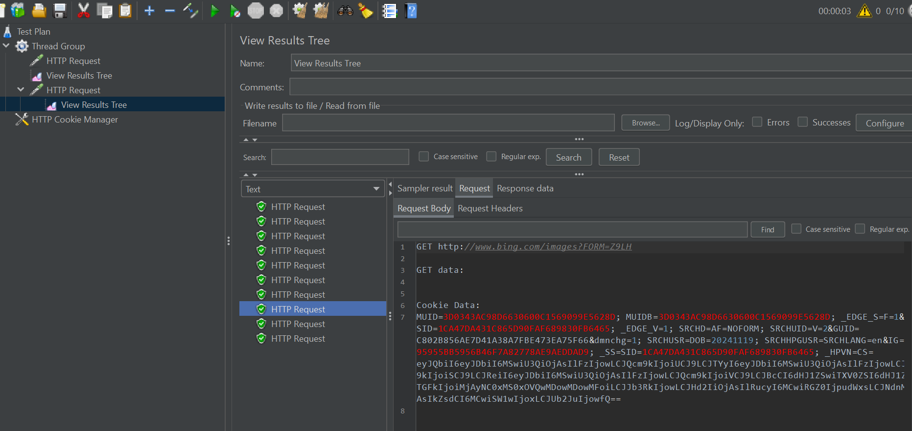

*Note: When creating user-define cookies HTTP Request and Domain Should be Same*

HTTP Cached Manager:

-----------------------------

HTTP Cached Manager is used to simulate Real time Browser Behavior. In Real time Browser is When user send the Request to server it will store the data in Local Machine Again user will click same page it will send the response from the Local machine. In Cache manager typically Store Response Memory.

Ex : HTML files , Images , CSS Files and JavaScript Files.

If we want to implement the cached manager Click on Config Element in that we have Option called HTTP cached Manager. You can see in below Screen shot , there we mention Loop number is 10 and Thread Count also 10 , it Suppose to send 100 request but if we see in Aggregate Table only 10 got sent Server.

***Note: Caching Page will implement for Static Page Only***

***For example, if you see amazon today’s deal page there is no caching page implemented because every day deal will change so backend code also will change.***

Basically, Once Created Virtual user (thread User) we don’t know which user sending request to serve So, if we want to know Which user sending request on Http Request, we have Option called Function helper Dialog. It will display which user sending Request.

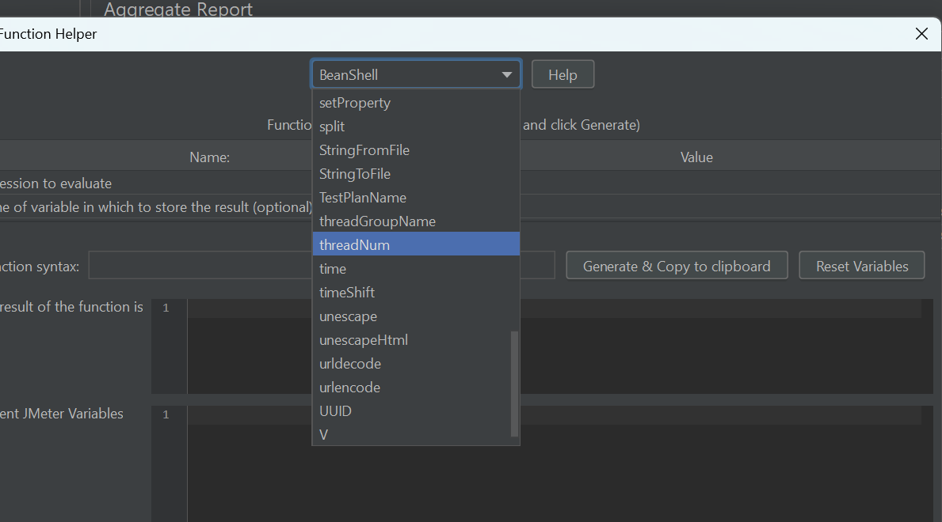

Data Driven Testing:

-------------------------

Data Driven Testing is Nothing But Testing Software Different Kind of Data to ensure robustness and Correctness of System.

In JMeter also We Can Conduct Data Driven Testing but JMeter will Support for Only .CSV files.